“Creating Lives” Signature Assignment Project
HIST 1302
United States History II

  - Part I (200 words minimum) (Utilizing your course readings and materials, introduce your character in two or three paragraphs. Provide historically- accurate and meaningful details regarding your character’s name, date and place of birth, current place of residence, race, ethnicity, sex, gender, class, and other relevant personal detail and information. Each of these personal characteristics must be identified and explained. In addition, create an avatar (or some other artistic representation) of your character and explain why you chose the characteristics depicted. (COM)
Rodriguez Gonzales, a male Mexican-American, who now resides in Hill County, Texas, has a vivid memory of a wide range of his early childhood experiences, including major historical events: social, political, economic, and religious. Born in 1942 in Matamoros, a town approximately 20 miles from the present-day’s South Padre Island. Gonzales is a middle-class Mexican American, married to Grace Morales with five children, two boys and three girls. Unfortunately, Gonzales is now crippled and relies on crutches and a wheelchair to move about. He was attacked by a Ku Klux Klan (KKK) member during a protest in South West America in 1967. The attack, Gonzales admit, followed his decision to join the civil rights movement in the quest for equality, fairness, and freedom in the United States (U.S.).

Gonzales’ Avatar
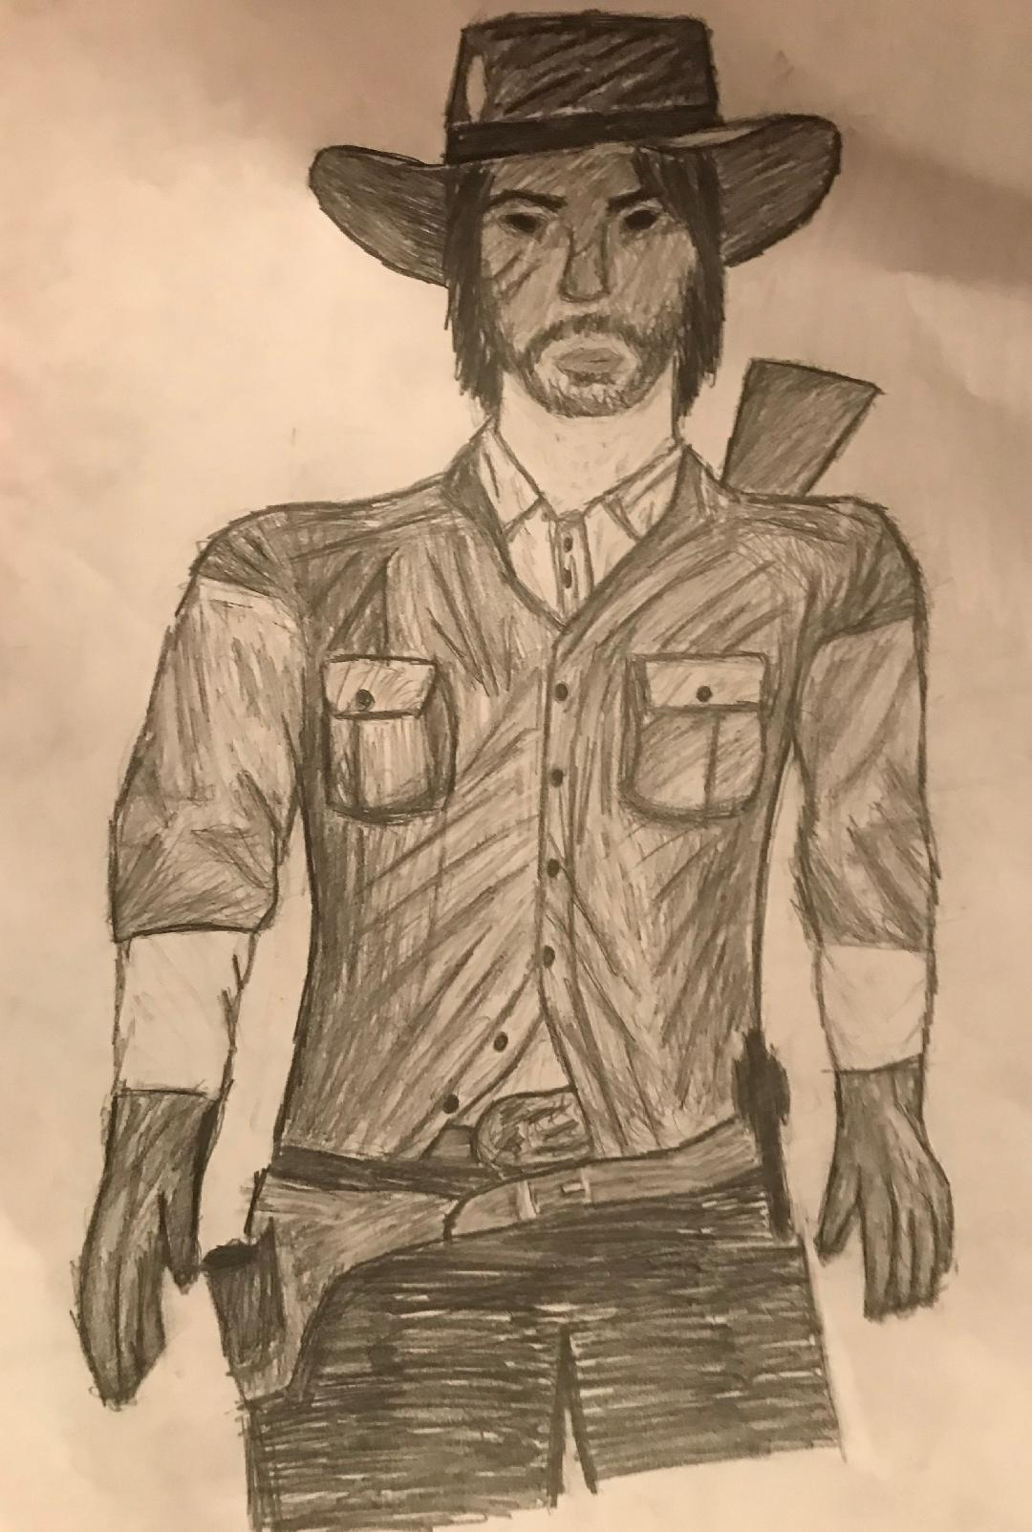
Characteristics. From the avatar, one can see that Gonzales is a well-muscled man. He has a knife and has two guns. This depicts his readiness and willingness to defend his family and ideals at all cost. Consequently, I have chosen to represent him this way because I believe he is confident, loving, and optimistic. Gonzales takes pride in his beliefs and other convictions as long as following them would result in freedom and the achievement of rewarding goals.
  - Part II (500 words minimum) (Analyze one of the major historic conflicts taking place in the time-period your character is living through (such as the Civil Rights movement, Vietnam War, Cold War, etc.) and is having a direct impact on the life of your character. Explain the historic antecedents or causes of such events. Be sure to identify the major historical figures and organizations that are associated with this event and the specific role(s) each played. Be sure to identify precise historical, social, political, economic, cultural, and global forces that shaped the event or conflict you are describing. Last, explain how this historical event or conflict affected or, perhaps, divided, Americans living in this era. (SLO1; SLO2, SLO3; CT; COM)
Gonzales early years in the U.S. were characterized by turbulence because the people of color, including African Americans, Chinese Americans, Hispanics, and Indian Americans were discriminated against. During this time, Gonzales recalls, the intention of leaders of the widely studied African American Civil Rights Movement was the inclusion of all Americans, regardless of their backgrounds. However, they focused on colored Americans because they underwent untold sufferings that resulted from discriminative laws. Following in the footsteps of President Martin Luther King, Hispanic Americans, Gonzales included, began to organize their own struggle with the sole purpose of achieving civil liberty. In particular, Puerto Ricans in Philadelphia, New York, as well as Chicago held marches, protesting unequal treatment. Likewise, individual Mexican Americans, who occupied the Southwest, created the Chicago Civil Rights Movement (CCRM).
Although these Hispanic groups shared common goals, ensuring equality and fairness, some of the socioeconomic and political issues they faced in the country were relatively different. For instance, Puerto Ricans were regarded as official American citizens, while Mexican Americans were treated with a great deal of suspicion as non-Americans. This unfair treatment applied irrespective of how many generations of a Mexican American had lived and worked in the U.S. Moreover, a considerable number of Puerto Ricans moved to towns and cities, but they had to survive in urban slums. The Mexican-American population mainly served as migrant workers, in addition to farming in the rural areas. They received meagre and unsustainable wages, which means Mexican Americans were exploited by the majority and upper class.
The Civil Rights Movement had far-reaching effect on Gonzales. The movement provided him with insight into the unfulfilled promises and treaties. He learned that, while the U.S. government had agreed to grant colonial Mexican settlers and new immigrants equal civil rights, their economic, social, and political aspects of life were increasingly deteriorating. As a result, Gonzales joined the activists to address a variety of principle issues of discrimination, ethnic stereotyping, educational segregation, a minimum wage, voting rights, as well as full citizenship. While he witnessed the grievances, the people had against the current U.S. authorities, he has never been too concerned about the socioeconomic, religious, and political issue as did most others in his circle. This explains the division that was witnessed among Americans who lived in this era. He was brought up to assume that the reason for discrimination against Mexicans was the belief that immigrants presented economic threats to whites. He however knew that racism would play a central role in destroying the peace in Texas and throughout the country. Consequently, Gonzales became an active participant in almost all the strikes, sit-ins, and demonstrations organized by the CCRM.

  - Part III (200 words minimum) (Find and analyze one primary source document directly related to the historical event or conflict you described in Part II. Explain the historical issue or issues raised in the primary source document. In other words, what does the document tell us and what insights does it shed on the historical event you discussed in Part II? In your review of this primary source, explain the view or perspective of the author of the document. What is the overall purpose of the document? Last, provide at least three examples or quotes from your document that help you understand the perspective of the person(s) who produced it. Last, consider how the issues raised in the primary-source document you analyzed would have reinforced or challenged your character’s worldview, ethical values, and/or historical perspective. Would your character agree or disagree with the view or perspective expressed by this document? Be sure you properly cite the source you use. (SLO2; CT; COM)

In his manuscript, “Hispanics – The forgotten class in civil rights history?” Nicholas Dauphine addresses the sensitive topic of biased representation of history. Touching on the ongoing tension between Texans of different ethnic and racial backgrounds in these neighborhoods, the author notes with a great of concern that scholars have failed Hispanics by not capturing their active role in the present-day’s American freedom (Dauphine, n.d.). Additionally, the author refers to a number of historic case laws and events, including Brown v. Board of Education, Plessy v. Ferguson, and assassination of President Luther King Jr. to demonstrate how history has been manipulated in a way that it overlooks the key role played by Hispanics. As stated earlier, the author concurs that Mexican Americans engaged in non-violent protests, were attacked, suffered casualties, but literature and the current U.S. system places much emphasis on other racial and ethnic groups, neglecting Hispanics.
The primary purpose of this document is to illuminate the role played by Mexican immigrants in the U.S. Civil Rights Movement, which has contributed to significant changes in economic, social, and political spheres. In the author’s worldview, while blacks and Hispanics and other minorities went through unbelievable tribulations in their fight for freedom, Mexican Americans’ sacrificed have been ignored by the media and scholars. Briefly speaking, the following three quotes express Schutze’s perspective:
“Where is he plight of Hispanics represented in the civil rights discussion and history of the U.S.?”
“How Hispanics were treated is no different from blacks.”
“When discussing civil rights milestone, where are the discussions about Hernandez v. Texas?”
I firmly believe that the author’s sentiments would have played a fundamental role in reinforcing Gonzales’ worldview because he valued hard work and honesty. Gonzales would have agreed with the author because, by the time of his death in 2010, Hispanics were not recognized as key players in the fight or liberty in the country.

  - Part IV (200 words minimum): Identify one major historically relevant ethical dilemma or moral choice that your character is struggling with in regards to this historical conflict. What personal or unique impact is this historical event having on your character? Be sure to explain how this ethical issue relates to this historical event and how the event is directly affecting your character (i.e., impacting his or her everyday experiences and/or challenging your character’s world and ethical view(s)). (SLO1; CT; COM)

The main ethical dilemma that faced Gonzales involves the decision to participate in the various protests and strikes that were organized by Civil Right Movement groups at a time when the police force and extremist groups posed real danger to his life. In essence, he had the challenge of weighing the benefits and risks or costs of joining the civil rights activists. Gonzales knew that being part of the movement against the U.S. authorities and white supremacists would have far-reaching negative effects on the country’s economic and social stability. Protests would mean more societal pressures, economic failure, and continued suspicion of neighbors, and a blown-out civil war.
In addition to the identified worries, Gonzales knew that joining the fight would most likely result in his death, leaving his family without a support system. Given he was brought up in a peace loving family, the dilemma troubled him to the core. He imagined a situation in in which his wife would be widowed and possibly die, the only land available taken away, and Mexican Americans failing to achieve their objective of being free in the long run. Further, he believed that the rebellion would go against his Christian beliefs, while at the same time, destabilizing the country, making it more susceptible to any forms of future attacks.
  - Part V (200 words minimum): Explain how your character has decided to respond to the ethical dilemma at hand and why he or she responded in the way you identified. Explain how your character’s cultural background and historical setting (i.e. the historical, social, political, economic, cultural and global forces), and the broader conceptions of ethical behavior embedded within, shaped your character’s response. Consider at least one of the following: (1) your character’s conception(s) of civic responsibility; (2) your character’s understanding of the importance and role of the democratic process; (3) your character’s respect for social justice, fairness, and difference; (4) your character’s experiences with prejudice, racial or gender discrimination, and/or economic and social marginalization. (SLO3; SR; COM)

As mentioned earlier, Gonzales weighed available options and decided to serve as an active participant in the civil rights protests in the Southwest. His wife, Morales, suggested that they leave for Mexico. Although it would be considerably challenging to find enough money to purchase land, rent a home, or build a life, Morales saw it was a worthy cause because its benefits surpassed the cost of fighting for what freedom in country she saw as foreign. On the other hand, Gonzales’ cultural and social background shaped his decision to take the risk because one of the core values he identified with involved protecting his brothers. Joining others in the fight against systematic racism would go a long way in securing the future of generations to come.
Among Hispanics, both nuclear and extended families constitute the most essential or important aspect of life. Consequently, the deciding and overriding though that fell upon Gonzales revolved around his conceptions of civic responsibility (Lee & Kawachi, 2019). While the decision would be against his family values, Gonzales was convinced that liberating society comes before family. Freedom for all Americans meant that his family and the larger lineage would be safer. Gonzales’ conceived civic responsibility as being liberal and patriotic. By revolting, he advocated a fair system of governance, and by choosing the safety of his countrymen, he was exercising his patriotism.
  - Part VI (200 words minimum): Last, explain how your character’s understanding of self and his or her related personal values influenced their response to the ethical dilemma faced and/or was altered by the historical events of the era he or she experienced. (PR; COM)
Like any other human being Gonzales has a unique primitive sense of what constitutes real self. According to Gonzales, his actions are a true reflection of his self. Before acting, he could look at and speak to himself in the mirror. In doing so, he was reassuring himself of the need to identify with and practice what is right, regardless of the outcome. This personal value manifested when he overcame his worries or doubts, as well as Morale’s discouragement, by joining the fight against the oppressive political system in the U.S. Gonzales’ staunch Christian values of service and endurance motivated him to break the boundaries set by strong family values as he prioritized equality and fairness freedom (Lee & Kawachi, 2019). Moreover, he suffered a crippling attack because of his stance, but all these did not deter him from solving the puzzle presented by the ethical dilemma of advocating liberty for all Americans. Equally important, Gonzales was driven by love and kindness because he believed in free and stable society characterized by peace.

References
Dauphine, N. (n.d.). Hispanics – The forgotten class in civil rights history. http://www.lbjlibrary.org/education/civil-rights-today-essay-contest/hispanics-the-forgotten-class-in-civil-rights-history
Lee, M. & Kawachi, I. (2019).The keys to happiness: Associations between personal values regarding core life domains and happiness in South Korea. PLoS ONE, 14(1): e0209821. https://doi.org/10.1371/journal.pone.0209821

